Ideation Phase
Define the Problem Statements

Date | 05 October 2026
Team ID | SWTID-2026-4248
Project Name | LearnMate AI StudyBuddy
Maximum Marks | 2 Marks

Customer Problem Statement Template:
Create a problem statement to understand your customer's point of view. The Customer Problem Statement template helps you focus on what matters to create experiences people will love.
A well-articulated customer problem statement allows you and your team to find the ideal solution for the challenges your customers face. Throughout the process, you’ll also be able to empathize with your customers, which helps you better understand how they perceive your product or service.

Reference: https://miro.com/templates/customer-problem-statement/
Example (LearnMate AI StudyBuddy – PS-1):
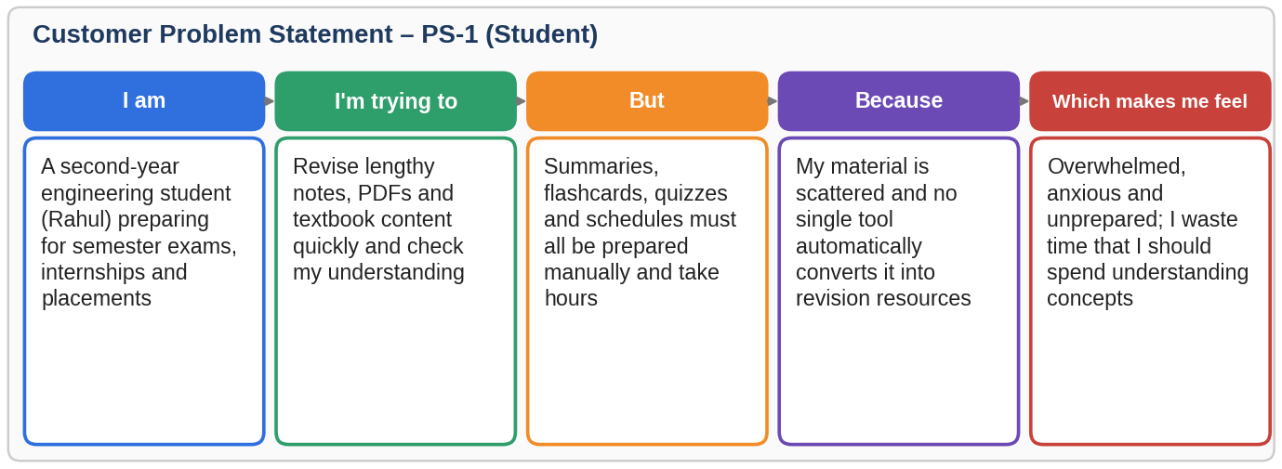
Problem Statement (PS) | I am (Customer) | I’m trying to | But | Because | Which makes me feel
PS-1 | A second-year engineering student preparing for semester exams, internships and placements | Revise lengthy notes, PDFs and textbook content quickly and test my understanding | Summaries, flashcards, quizzes and schedules have to be prepared manually and take hours | My study material is scattered and no single tool automatically converts it into revision resources | Overwhelmed, anxious and unprepared
PS-2 | A student balancing academics with skill-building who has limited daily study time | Follow a realistic study schedule and assess what I have learned before the exam | I get generic plans and no practice questions based on my own material or available hours | Existing apps are separate for notes, quizzes and planning, and none personalise to my goal and time | Unproductive, unsure of my progress and stressed
PS-3 | A platform administrator responsible for the StudyBuddy service | Monitor registered users and manage platform content securely | There is no controlled way to view users, remove accounts or see usage statistics | Without role-based access, user and material management cannot be restricted to authorised staff | Concerned about security and loss of control

